

Azure Site Recovery - Partner Offering

[Offering Template]

Prepared by: Peter De Tender

pedete@microsoft.com

Azure CAT GSI

Document Version: 1.0 Last Update date: October 17, 2016

**Template Guidance**

This document is a suggested services and solution offering template on Azure Site Recovery - ASR, exclusively towards AzureCAT GSI Partners, who are interested in providing a) Azure Disaster Recovery, b) Azure Business Continuity and c) Virtual Machine lift & shift migration solutions and services towards their customers. Take the following points into consideration when reusing this template:

* Azure Site Recovery – ASR, is part of the broader Operations Management Suite OMS) cloud solution, which also offers Azure Backup. This template specifically handles the disaster recovery aspects and architectures, without taking Azure Backup or OMS monitoring outside of ASR monitoring into consideration.
* The discussed architectures, workload estimates and cost estimates assumes Azure as a target for failover in these scenarios, not an on-premises to on-premises replication scenario.
* This template should be seen as a “document in progress”, which will be updated regularly, based on feedback from AzureCAT GSI Partners, AzureCAT GSI team members or based on major changes in the solution itself.

# Contents

**Contents** 2

Azure Site Recovery solution and service offering 4

Solution Description 4

Where can you win? 5

Getting Started 5

Value Proposition 6

TOP 10 questions to start the discussion with the customer 6

Disaster Recovery Challenges 7

Familiar DR solutions 7

Microsoft’s typical DR stack 8

Azure DR Solutions Overview 9

Azure Site Recovery 9

ASR topology choices 9

Recommended Project Approach 10

Assessment 10

Azure Site Recovery – Reference Architecture 11

Azure Site Recovery Design Guidance 12

Proof of Concept offering 13

In scope scenarios for the Proof Of Concept 14

Suggested statement of work for the Proof of Concept 14

Azure Site Recovery - Cost Scenarios 15

Azure Cost components for any DR scenario 15

Pricing – Bundled Offering (Requires annual pre-commitment) 16

Pricing - Pay as you Go 17

Pricing – Sample Scenario – Cost Overview 18

Assumptions 18

Azure Pricing Components 19

Summary 19

# Azure Site Recovery solution and service offering

## Solution Description

According to multiple studies done by IT sector companies, organizations experience up to four major disruptions annually, which can cost them anywhere between $60,000.00-$600,000.00 or even more per incident, depending on the business area they are active in, and the criticality of the outage. If the disruptions prevent organizations from meeting their own business requirements and customer needs, or bring them out of compliance with key government regulations, impacts can be even more significant and far-reaching. Meaning it is not only an IT issue anymore.

This solution and services offering template discusses Microsoft Azure Site Recovery (ASR), to provide a workload-aware, best-in-class disaster recovery solution, allowing organizations to recover from workload and machine disruptions within minutes— with no or minimal data loss, depending on the workload.

Azure Site Recovery helps you protecting important applications by coordinating the replication and recovery of physical or virtual machines out of ASR. Key benefits for using this Azure cloud based technology are ease of implementation, having a massive reduction in costs compared to building out your own datacenter DR solution, and workload aware application integration.

Azure Site Recovery can be tailored to fit the needs of your data security and compliance standards.

Your Microsoft Partner will work with you on the following items through the offering lifecycle:

* Requirements gathering (data compliance policies, required workloads and instances to protect, service level agreements, communication plans);
* End-to-end project management for the duration of the engagement defined in the requirements gathering;
* Creation and migration/replication of all designated instances;
* Service management (datacenter and site monitoring, incident logging, communications);
* additional service add-ons and products – suggested list below;
* Service management (datacenter monitoring, technical support/SLA)
* Communication and customer management
* Customized <Partner> private cloud options (geo, configurations,…)
* Data warehousing, process optimization and recommendations, BI/analytics

## Where can you win?

To decide if Azure Site Recovery should be added to the GSI Partner’s portfolio, use the following market potential as guideline:

* High Success Potential
  + Customer relies only on backup as disaster recovery solution today
  + Small / Mid-market / Enterprise branch who don’t have a solid disaster recovery solution today
  + Mainly running Windows-based workloads (or supported Linux)
  + Customers looking for easy lift & shift VM workload migrations to Azure
  + Cloud minded customer
* Medium Success Potential
  + Customers looking for easy lift & shift VM workload migrations to Azure for Dev/Test images
  + Small / Mid-market / Enterprise branch, interested to replace or optimize their existing disaster recovery solution today
  + Small / Mid-market / Enterprise branch, interested in avoiding single-vendor disaster recovery solution today
  + Cloud aware customer
* Low Success Potential
  + Large enterprise looking for a single DR solution
  + Cloud averse customer
  + Customer running non-Azure supported workloads

## Getting Started

With Backup and Recovery, the power of Azure is just a few clicks away. Simply connect your datacenter to <Partner> ‘s datacenter or Azure with Backup and Recovery, and your data and applications will be available in Azure when needed.

* Eliminate the need to build and maintain a secondary disaster recovery site.
* Save time and money, by eliminating tape backup, and house up to 99 years of backup data in Azure.
* Easily migrate running Hyper-V or SCVMM, physical, VMware and Amazon AWS workloads into Azure to leverage the economics and elasticity of the cloud.
* Run compute-intensive reports or analytics on a replicated copy of your on-premises asset in Azure—without impacting production workloads.
* Burst into the cloud and run on-premises workloads in Azure—with larger compute templates, as needed, to give you the power you need, when you need it.
* Create multi-tier development environments in Azure with a few clicks; even replicate live production data to your dev/test environment to keep it in near real-time sync.

## Value Proposition

Key strengths of Azure DR solutions (Azure Site Recovery and Azure Backup) are:

**Heterogeneous Replication** – ASR protects physical & virtual environments, irrespective of underlying hardware

**Near-Zero RPO** - lightweight mobility service on the primary servers to track & replicate data changes continuously in real-time

**N-tier Application Consistency** - guest level app discovery & enforces consistency across all VMs in a multi-tier app

**Best-in-class RTO** - end-to-end recovery orchestration such as network adaptation & sequencing to minimize site level RTO

**Maturity & Experience –** 1000+ customers, multiple patents & support for a wide range of different platforms

## TOP 10 questions to start the discussion with the customer

<list of key questions to discuss with the customer and align on the solution>

1. Tell me about your strategy and solutions for protecting your physical, virtualized and hosted applications and data?
2. Will those solutions continue to meet your needs as you explore the benefits of cloud computing?
3. How has the growth in VM’s and data affected your ability to effectively protect your applications?
4. Does the cost of legacy DR solutions align to your cost objectives as you move to the next stage?
5. How frequently do you test your BCDR solution with planned failovers? Is that a simple process?
6. What types of Recovery Plans have you developed and is it simple to modify or update those plans?
7. How does your current solution automate the failover and recovery process?
8. What is your Recovery Point Objective and do you have an SLA? Do you meet the SLA?
9. What is your Recovery Time Objective and do you have an SLA? Do you meet the SLA?
10. What would be the financial impact to the company if you were unable to meet your recovery SLA’s?

# Disaster Recovery Challenges

## Familiar DR solutions

For many years, a “typical DR solution” was comprised of the following components:

* Geo-stretched over multiple datacenters;
* (Expensive) Storage Area Network – SAN based solutions;
* SAN replication between multiple datacenters;
* Active / Passive or Active / Active setup;
* Combination of physical redundant hardware, hypervisor technology and software clusters;
* Complex to implement, manage, monitor;

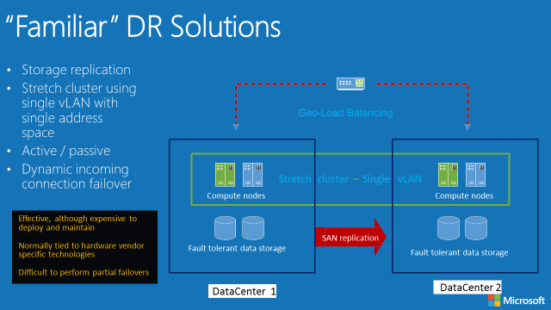  
Figure 1: “Familiar” DR solutions

## Microsoft’s typical DR stack

Along the years, Microsoft has been offering and integrating DR functionality in different stacks of the Server product portfolio:

* Physical and/or virtual machines, running Windows Operating Systems;
* Windows Server Hyper-V hypervisor, providing Hyper-V replication for DR;
* Guest VM application cluster technology (SQL Server AlwaysOn, Exchange DAG,…);
* Storage Spaces on Windows Server 2012 R2 and 2016, offering SAN-storage replacement capabilities;
* Windows Backup or System Center Data Protection Manager (DPM) for backups and system archiving and retention;
* A combination of multiple solutions mentioned above in the same topology;

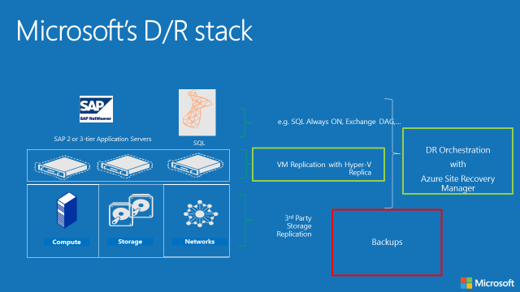  
Figure 2: Microsoft’s typical D/R stack

# Azure DR Solutions Overview

## Azure Site Recovery

<Partner>’s offered Azure Site Recovery DRaaS (Disaster Recovery as a Service) solution helps you protect important applications by coordinating the replication and recovery of physical or virtual machines (Source VMs can be running in VMware ESX, Amazon AWS, Hyper-V hosts or System Center Virtual Machine Manager clouds). This offering allows you to avoid the expense and complexity of building and managing your own recovery solution, by enabling automated replication of your datacenter to either your own secondary location or in the Microsoft Azure cloud datacenters (note that Azure Site Recovery is not available in all Azure datacenter regions yet). Doing so will deliver a best-in-class disaster recovery solution, making it possible for you to recover from disruptions within minutes and with minimal data loss and impact on the business.

## ASR topology choices

Azure Site Recovery provides the following replication streams:

1. Hyper-V to Hyper-V replication (on-premises between 2 datacenters)
2. Hyper-V to Hyper-V SAN storage replication (on-premises between 2 datacenters)
3. Hyper-V or SCVMM replication to Azure ASR Vault
4. VMware / physical to VMware / physical replication (on-premises between 2 datacenters)
5. VMware / Amazon AWS / physical to Azure ASR Vault

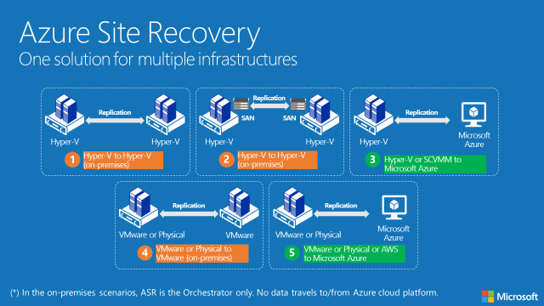  
Figure 3: Azure Site Recovery replication streams

# Recommended Project Approach

To guarantee a successful implementation of Azure Site Recovery, the following project approach could be used as a guideline (Note: these project steps should be tailored to the partner’s already existing practices and terminologies):

Figure 5: Azure Site Recovery recommended project approach

|  |  |
| --- | --- |
| Project Phase | Description |
|  |  |
| Plan | This phase is the first in the full project cycle, where sales team does a handover to presales execution team. Here you explain the different project stages to the customer and establish a planning for execution. |
| Assess | During this phase, an assessment of the IT environment at the customer will be performed, outlining the BCDR requirements per workload, per application, what the RPO/RTO should be, what are the business requirements and alike. |
| Design | The result of this phase is a design document, based on the information gathered from the assessment, with a full overview of the to-be ASR and Azure Backup architecture, features and parameters needed to build the solution. |
| Implement | This is the actual consulting required to implement the solution, according to the design document. This can be done in a fixed price or time and material concept. One should consider a test and production deployment with approval steps and milestones in between. |
| Monitor | Once ASR and Azure Backup has been implemented and is operational, the solution should be monitored and followed-up on. Microsoft Operations Management Suite (OMS) or 3rd party tools should be considered here as part of the overall solution. |
| Maintain | The maintenance phase involves patching, updating, fixing issues where occurring, to guarantee the correct business outcome of the implementation. |
|  |  |

## Assessment

We understand the complexity of the assessment phase in a BCDR project. Next to gathering the as-is situation, one also need to map the to-be situation in Azure. Where the biggest concern is cost and knowing consumption limitations to control these. Out of the ASR Product Team, we recommend the **Azure Site Recovery Capacity Planner Tool**, which helps you to figure out your capacity requirements for protecting Hyper-V, SCVMM, VMware or physical server workloads.

Use the Site Recovery Capacity Planner to analyze your source environment and workloads, and figure out bandwidth needs, server resources you'll need in your source location, and the resources (virtual machines and storage etc), that you'll need in your target location.

You can run the tool in a couple of modes:

•Quick planning: Run the tool in this mode to get network and server projections based on an average number of VMs, disks, storage, and change rate.

•Detailed planning: Run the tool in this mode and provide details of each workload at VM level. Analyze VM compatibility and get network and server projections.

For more detailed information regarding the Azure Site Recovery Capacity Planner Tool, refer to the following article in the Azure documentation: <https://azure.microsoft.com/en-us/documentation/articles/site-recovery-capacity-planner/>

## Azure Site Recovery – Reference Architecture

Once the assessment is complete, the design phase follows. To assist partners in this phase, we developed the “Azure Site Recovery and Azure Backup Reference Architecture”, outlining the overall architectural concepts of the Azure Site Recovery and Azure Backup solutions.

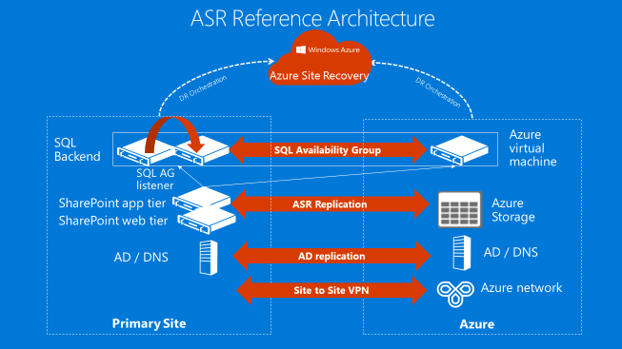  
Figure 6: Azure Site Recovery – Reference Architecture

|  |  |
| --- | --- |
| ASR Component | Functionality |
|  |  |
| Primary Site | The primary site at the customer, known as the “source”. This can be physical servers, VMware, Hyper-V, SCVMM or AWS machines. |
| Azure | Microsoft Azure cloud datacenter, known as the “target”. |
| Site to Site VPN | Encrypted Network connectivity between a customer’s primary site and Azure, allowing for site-to-site traffic communication, recommended or required for application access. (Note: Azure Site-to-Site VPN is not required for ASR replication itself) |
| ASR Replication | Any ASR-enabled source machine’s changes (system and data), will be replicated to an equally sized Azure VM. This replication cycle can be configured from 30 sec – 15 minutes. |
| SQL Availability Group | In case of a SQL Server database, ASR can integrate with SQL server to perform a consistent replication and failover. SQL AlwaysOn clustering is also supported as part of ASR. |
| Active Directory | It is recommended to host a dedicated Azure VM as additional or dedicated Active Directory Domain Controller in an Azure VNet and Subnet, to guarantee application connectivity to the Active Directory domain, once the failed over application servers are running in Azure. |

|  |  |
| --- | --- |
| Feature References | |
| Azure Site Recovery Overview | <https://azure.microsoft.com/en-in/documentation/articles/site-recovery-overview/> |
| Best Practices for Site Recovery Deployment | <https://azure.microsoft.com/en-in/documentation/articles/site-recovery-best-practices/> |

(Note: This is an overall architecture, mentioning the core components of a typical ASR solution. Consult the detailed ASR documentation for more details: <https://azure.microsoft.com/en-us/documentation/articles/site-recovery-overview/>

## Azure Site Recovery Design Guidance

Azure Site Recovery (ASR) can be an effective DR solution for businesses that don’t necessary have the resources to setup a secondary failover datacenter. Azure Site Recovery can back up your virtual machines to azure in a seamless process. Here is some design guidance:

* Currently Azure Site Recovery only supports Hyper-V Generation 1 VMs. In a failover event your Gen2 virtual machines will be converted to Gen1 on azure and will convert back to Gen2 on your failover back to the on-premises site.
* With the support for larger operating system drive size, ASR also removes restrictions on operating system drives that are larger than 127 GB.
* ASR adds support for subnet mapping and for multiple network adapters on VMs that fail over to Azure, retaining the VM’s IP address post failover to Azure.

|  |  |  |
| --- | --- | --- |
| Scenario | Model | Points to Consider |
| Azure Site Recovery | Any Business Model | * Compute costs are incurred when you trigger a failover. Virtual machines in normal modes would not exists in Azure. * When configuring frequency of replication you might want to access the bandwidth impact of each setting through the calculator. * Leverage hybrid network between on-premises and azure to ensure clients resume communications to the failover Azure VMs |

## Proof of Concept offering

Before doing the actual production implementation of Azure Site Recovery and/or Azure Backup, a Proof of Concept – POC is recommended.

This paragraph describes a possible POC offering for this solution.

The purpose of the Azure Site Recovery POC is getting a better understanding of the cost saving potential of Azure-based Disaster Recovery functions in the context of the customer’s datacenters, as well aligning on the technical aspects of the offered solutions. This understanding can be broken down into the following topics;

1. **Technical feasibility**. Understand the technical prerequisites to transition workloads from one of the customer’s datacenters to Microsoft Azure, by leveraging on ASR and/or Azure Backup.
2. **Benefits**. Understand how benefits can be yielded as a result of the transition of workloads to Microsoft Azure, by leveraging on ASR and/or Azure Backup.
3. **Cost model**. Understand how Microsoft Azure will charge for the consumption of services and how the billing information should be interpreted and used.
4. **Systems management impact**. Understand how existing systems management processes will need to change as public cloud based services will be employed.

The focus of the POC should be around the **first 3 topics**. A positive outcome of this POC could lead to an more thorough investigation of the systems management impact for the customer, by suggesting Operations Management Suite as one possible solution.

### In scope scenarios for the Proof Of Concept

<this paragraph lists the in scope scenarios for the Proof Of Concept, which might need to be tailored to the partner’s and customer’s specific situation.>

The ASR and/or Azure Backup POC will focus on the demonstration of the technical feasibility, benefits and cost models of the following scenarios:

1. Disaster Recovery
   1. Replicate 1-5 running (supported) physical servers and/or virtual machines (Hyper-V, SCMM or VMware) from the customer’s datacenter to Azure (Region of choice)
   2. Demonstrate a manual test failover
   3. Demonstrate a manual unplanned failover / failback
   4. Demonstrate a manual planned failover / failback
   5. Demonstrate the usability of ASR Recovery Plan custom scripts, allowing for a more complex failover scenario (eg. Sharepoint, SQL Server,…) if valid

### Suggested statement of work for the Proof of Concept

To execute the aforementioned Proof of Concept, use the following workload estimates as a guideline:

|  |  |  |
| --- | --- | --- |
| Activity | Steps | Effort |
|  |  |  |
| Azure Site Recovery POC | 1. Replicate 1-5 running (supported) physical servers and/or virtual machines (Hyper-V, SCMM or VMware) from the customer’s datacenter to Azure (Region of choice) 2. Demonstrate a manual test failover 3. Demonstrate a manual unplanned failover / failback 4. Demonstrate a manual planned failover / failback 5. Demonstrate the usability of ASR Recovery Plan custom scripts, allowing for a more complex failover scenario (eg. Sharepoint, SQL Server,…) if valid | 5 days – 40 hours |
|  |  |  |
|  |  |  |
| Create POC report | 1. Create conclusions report of the Azure Site Recovery and/or Azure Backup Proof of Concept | 1 day – 8 hours |

# Azure Site Recovery - Cost Scenarios

Besides the technical aspects of the solution, Azure consumption cost is another important component to keep in mind. This section describes the core Azure consumption costs for Azure Site Recovery (Individually licensed or as part of Operations Management Suite – OMS bundle), based on different pricing options available. Use these as a guidance to estimate the total cost for implementing the Azure DR solution at customers.

## Azure Cost components for any DR scenario

In general, building out an Azure-based DR scenario, requires the following Azure cost components:

* Azure Site Recovery licenses
* Azure IAAS running cost for the VMs (after 31 days):
  + Hourly run cost of the VMs within the DR scenario (=DR test plan)
  + Hourly run cost for permanently running VMs in Azure (eg. ADDS VM)
  + Azure Site-to-Site VPN for hybrid application connectivity
* Azure DR storage
  + Azure Site Recovery storage cost
  + Azure backup storage cost
* Network bandwidth
  + Network bandwidth recurring costs
  + ExpressRoute (if required)

Note: Consult the Azure Pricing website and Pricing Calculator tool for up-to-date cost estimates (<https://azure.microsoft.com/en-us/pricing/>)

Pricing overview on the next pages is valid at the time of writing this document, October 2016, and valid for changes, and based on public list pricing.

## Pricing – Bundled Offering (Requires annual pre-commitment)

|  |  |
| --- | --- |
| Suite | Price (per month) |
| **Insight & Analytics suite**   * *Insight & Analytics* * *SCOM* | **$15/ node** |
| **Automation & Control suite**   * *Automation & Control* * *SCCM & Orchestrator* | **$10/ node** |
| **Security & Compliance suite**   * *Azure Security Center* ***or*** * *OMS Security & Compliance* | **$15/ node** |
| **Protection & Recovery suite**   * *Backup* * *Site Recovery – E2E & E2A* * *VMM & DPM* | **$30/ node** |

|  |  |
| --- | --- |
| Suite | Price (per month) |
| **OMS E1**   * *Insight & Analytics* * *Automation & Control* * *All of System Center* | **$20/ node** |
| **OMS E2**   * *Insight & Analytics* * *Automation & Control* * *Security & Compliance* * *Backup* * *Site Recovery – E2E & E2A* * *All of System Center* | **$35/ node** |

## Pricing - Pay as you Go

|  |  |
| --- | --- |
| Service | Price (per month) |
| Insight & Analytics  *(includes Log Analytics)* | **$15/ node** |
| Automation & Control | **$10/ node** |
| Security & Compliance **or**  Azure Security Center | **$15/ node** |
| Backup | **$10/ node** |
| Site Recovery – E2E (on-premises replication) | **$16/ node** |
| Site Recovery – E2A (to Azure replication) | **$25/ node** |
| Log Analytics | **$2.3 per GB** |
| Automation | **$0.002 per min** |

## Pricing – Sample Scenario – Cost Overview

In this sample scenario, we describe a typical 3-tier application architecture in high availability (SQL AlwaysOn) configuration with SQL Server, which will be replicated to Azure by using Azure Site Recovery. To allow for application access in case of disaster, we also provide Site-to-Site VPN access (internal users) and Azure Traffic Manager (external users).

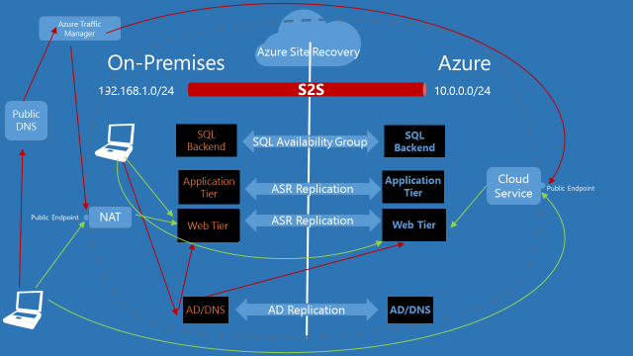

## Assumptions

* Active Directory and DNS VM will be replicated using Active Directory and DNS replication
  + 4Gb RAM, 2 cores, 127Gb system drive
* SQL cluster database will be replicated using SQL AlwaysOn (Database = 2Tb)
  + 32Gb RAM, 8 cores, 127Gb system drive
  + Data drive 3Tb
  + Log drive 1Tb
* Application Tier VM will be replicated using Azure Site Recovery
  + 16Gb RAM, 4 cores, 127Gb system drive
  + Data drive 1Tb
* Web Tier VM will be replicated using Azure Site Recovery
  + 16Gb RAM, 4 cores, 127Gb system drive
  + Data drive 1Tb
* Site-to-Site VPN will be configured between both networks
* Azure Traffic Manager will be set up to allow public internet rerouting of the web app

## Azure Pricing Components

|  |  |  |
| --- | --- | --- |
| Service type | Description | Estimated Cost |
| Virtual Machines for ADDS | 1 Standard virtual machine(s), D2 v2 (2 cores, 7 GB RAM, 100 GB disk, $0.266/hr) size: 744 hours | $197,90 |
| IP Addresses | arm type, 2 public IP Address(es) x 744 hours | $5,95 |
| Traffic Manager | 1 million(s)/mo queries, 1 Azure endpoints, 1 external endpoints | $1,44 |
| VPN Gateway | standard tier, 744 gateway hour(s), 250 GB outbound vpn | $162,68 |
| Storage | 6 TB storage Block blob type. Basic tier, LRS redundancy, 2000 x100,000 transactions | $152,61 |
| Site Recovery and OMS bundle | 0 instance(s) of Recovery to customer-owned sites, 2 instance(s) of Recovery to Azure (10 OMS E1 licenses + 2 OMS E2 licenses) | $270,00 |
| Virtual Machines for App Tier | 1 Standard virtual machine(s), D4 v2 (8 cores, 28 GB RAM, 400 GB disk, $1.063/hr) size: 74 hours (=+/- 8 days DR test) | $79,09 |
| Virtual Machines for Web Tier | 1 Standard virtual machine(s), D4 (8 cores, 28 GB RAM, 400 GB disk, $1.120/hr) size: 74 hours (=+/- 8 days DR test) | $83,33 |
| Virtual Machines for SQL AlwaysOn | 1 Standard virtual machine(s), D4 v2 (8 cores, 28 GB RAM, 400 GB disk, $4.063/hr) size: 744 hours, SQL Enterprise license | $3 022,87 |
| Support | **Support** | $0,00 |
|  | **Monthly Total** | **$3 975,87** |
|  | **Annual Total** | **$47 710,39** |
|  |  |  |

# Summary

This Azure DR solutions offering template provided several guidelines towards GSI partners, in order to easily offer Azure DR solutions to their customers, based on Azure Site Recovery.

This offering document should be used as a guideline template, customized to the partner’s needs and tailored to the customer’s specific requirements and scenarios.